

**UNIVERSITY OF BARISHAL**

***Report On***

**Determination of The Contents of Cold Drinks**

**Course Name: Computer Fundamentals and Office Applications**

**Submitted To:**

**Md Mahbub E Noor**

**Lecturer**

**Department of Computer**

**Science & Engineering**

**University of Barishal.**

**Submitted By:**

**Jubayer Hosen**

**ID: 13, Batch: 53**

**Department of Chemistry**

**University of Barishal.**

**Date of Submission: 16 December 2024**

**AIM**

Comparative study and qualitative analysis of different brands of cold drinks available in market.

**PURPOSE**

In recent days, soft drink brands were put into various questions regarding their purity. News flashed that they contain harmful pesticide, which arouse many interest in knowing its contents because I have been drinking them for years. I wanted to confirm that whether the charge imposed on these brands are true or not.

Another fact which inspired me to do this project is that I am in touch with qualitative analysis whose knowledge with other factors helped me to do so.

**Table of Contents**

* Introduction
* Theory
* Apparatus
* Chemicals Required
* Detection of pH
* Test for Carbon Dioxide
* Test for Glucose
* Test for Phosphate
* Test for Alcohol
* Test for Sucrose
* Result
* Conclusion

INTRODUCTION

The era of cold drinks began in 1952 but the industrialization in India marked its beginning with launching of Limca and Goldspot by parley group of companies. Since, the beginning of cold drinks was highly profitable and luring, many multinational companies launched their brands in India like Pepsi and Coke.

Now days, it is observed in general that majority of people viewed Sprite, Miranda, and Limca to give feeling of lightness, while Pepsi and Thumps Up to activate pulse and brain.

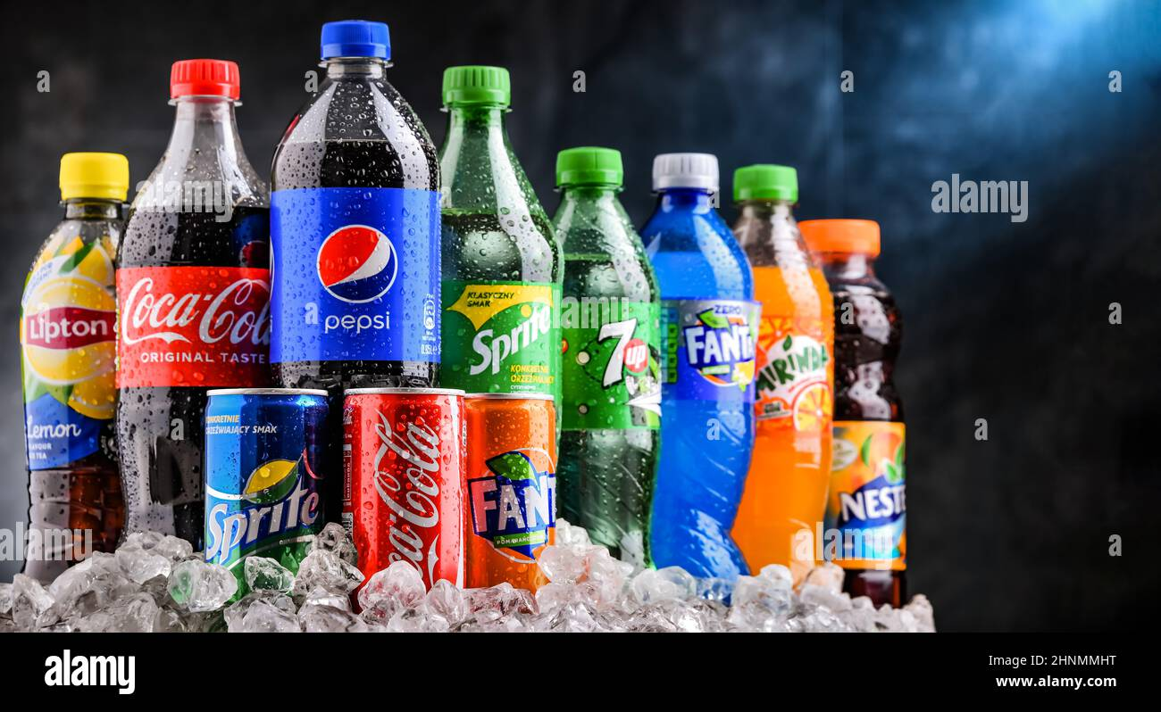

Soft drinks are non-alcoholic water-based flavored drinks that areoptionally sweetened, acidulated and carbonated. Some carbonatedsoft drinks also contain caffeine; mainly the brown-colored coladrinks.

Soft drinks are called "soft" in contrast to "hard drinks" (alcoholic beverages). Small amounts of alcohol may be present in a softdrink, but the alcohol content must be less than 0.5% of the totalvolume if the drink is to be considered non-alcoholic.

Also called soda, pop, coke, soda pop, fizzy drink, tonic, seltzer,sparkling water or carbonated beverage.

The first marketed soft drinks in the Western world appeared in the17th century. They were made from water and lemon juicesweetened with honey.

Theory

Cold drinks of different brands are composed of alcohol, carbohydrates, carbon dioxide, phosphate ions etc. These soft drinks give feeling of warmth, lightness and have a tangy taste which is liked by everyone. Carbon dioxide is responsible for the formation of froth on shaking the bottle.

The carbon dioxide gas is dissolved in water to form carbonic acid which is also responsible for the tangy taste. Carbohydrates are the naturally occurring organic compounds and are major source of energy to our body. General formula of carbohydrates is

CX (H2O)Y

On the basis of their molecule size carbohydrates are classified as:-

Monosaccharide, Disaccharides and Polysaccharides. Glucose is a monosaccharide with formula C6H12O6 .It occurs in Free State in the ripen grapes in bones and also in many sweet fruits. It is also present in human blood to the extent of about 0.1%. Sucrose is one of the most useful disaccharides in our daily life. It is widely distributed in nature in juices, seeds and also in flowers of many plants. The main source of sucrose is sugar cane juice which contain 15-20 % sucrose and sugar beet which has about 10-17 % sucrose. The molecular formula of sucrose is C12H22O11. It is produced by a mixture of glucose and fructose. It is non-reducing in nature whereas glucose is reducing. Cold drinks are a bit acidic in nature and their acidity can be measured by finding their pH value. The pH values also depend upon the acidic contents such as citric acid and phosphoric acid.

Apparatus

* Test Tube
* Test Tube Holder
* Test Tube Stand
* Wire Gauge
* Water Bath
* Stop Watch
* Beaker
* Burner
* pH Paper
* Tripod Stand
* China Dish

**Chemicals Required**

* Iodine Solution
* Potassium Iodine
* Sodium Hydroxide
* Fehling’s A & B Solution
* Lime Water
* Concentrated HNO3
* Benedict Solution
* Ammonium Molybdate

**Soft Drink Industry Market**

**Global Scenario**

* Globally, carbonated soft drinks are third most consumed beverages.
* Per capita annual consumption of carbonated.
* Soft drinks is nearly four times the per capita consumption of fruit beverages .
* Soft drink consumption is growing by around 5% a year, accordingto the publication Global Soft drinks 2002.
* Total volume reached 412,000 million litres in 2001, giving aglobal per capita consumption of around 67.5 litres per year.

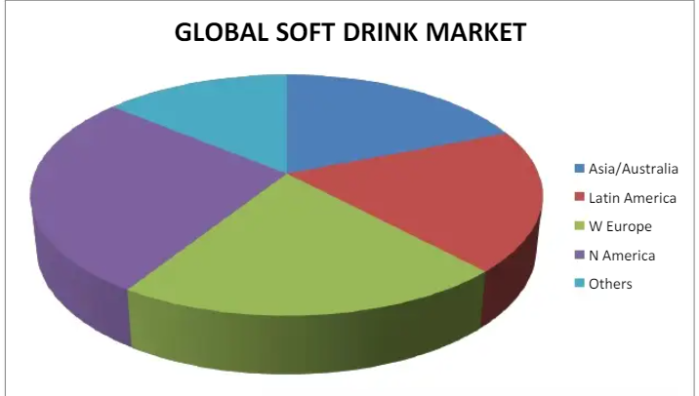

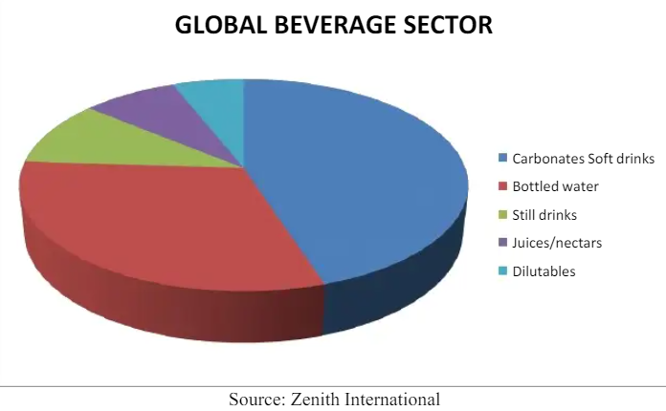

**Ingredients**

Most soft drinks are characterized by carbonated water, sugar, andcaffeine. Variations in soft drinks generally advertise either flavor differences, or the absence of one or more of the three main ingredients.

**Cola**

The largest segment of the soft drink industry is the colas. Colas wereoriginally blends of extracts of the coca leaf and the cola nut, mixed withsugar water. The coca leaf is no longer used, but the cola nut remains inthe recipes that are public, and reportedly is also still in the secret Coca-Cola recipe. The cola nut comes from the Ivory Coast in Africa, primarily from two species of trees, *Cola acuminata* and *Cola nitida.*

**Sweeteners**

Sugar has been largely replaced by high fructose corn syrup, largely because the latter is not price controlled, and is a little bit sweeter, soless is needed. The artificial sweetener aspartame is the low-caloriesweetener of choice at the time this is being written, having replacedcyclamates and saccharin as the favorites.

**Flavors**

Acids are added to soft drinks for extra bite, and mouth feel. The primary acid used in colas is phosphoric acid, while the one used incitrus flavored drinks is usually citric acid. Carbonated water (water thathas the gas carbon dioxide dissolved in it under pressure) is also mildlyacidic (it is chemically carbonic acid, H2CO3).

**Preservatives**

Sodium benzoate is used as a broad spectrum antimicrobial, inhibiting bacteria, molds, and yeasts. The high acid content of the soft drink isnecessary for the preservative action. Sodium citrate buffers the acids, sothe pH stays low (acidic). It also emulsifies any fats or fat-solublecompounds in the flavorings, keeping them in solution.Potassium sorbate is added to inhibit yeasts and fungi.Ascorbic acid (Vitamin C) is used as an anti-oxidant.

**Colors**

In colas, the color comes from caramel coloring (burnt sugar). Red40 and other colors are used in fruit flavored drinks such as orange soda.

